Online Voting System

***Project Report***

*Web Technology Lab (21B12CS322)*

*Project Based Learning*

*ODD Semester 2021*



**Department of CSE/IT**

**Jaypee Institute of Information Technology University, Noida**

Submitted to:

**Dr. Naveen Kumar Gupta Sir**

**Jyoti Ma’am**

## Members:

Jayant Singh Amethia (19102021)

Kritika Singh (19102079)

Anmol Arora (19102110 )

# ACKNOWLEDGEMENT

We would like to place on record our deep sense of gratitude to Dr. Naveen Kumar Gupta, Jaypee Institute of Information Technology, India for his stimulating guidance, continuous encouragement and supervision throughout the course of present work.

We express our sincere gratitude to everyone at Dept. of CSE/IT, Jaypee Institute of Information Technology, Noida India, for their generous guidance, help and useful suggestions.

We also wish to extend our thanks to our teammates and other classmates for their insightful comments and constructive suggestions to improve the quality of this project work.

Jayant Singh Amethia (19102021)

Kritika Singh (19102079)

Anmol Arora (19102110)

# ABSTRACT

The word "vote" means to choose from a list, to elect or to determine. The main goal of voting (in a scenario involving the citizens of a given country) is to come up with leaders of the people's choice.

Most countries, Kenya not an exception have problems when it comes to voting. Some of the problems involved include ridging voles during election, insecure or inaccessible polling stations, inadequate polling materials and also inexperienced personnel.

This online voting/polling system seeks to address the above issues. It should be noted that with this system in place, the users, citizens in this case shall be given ample time during the voting period. They shall also be trained on how to vote online before the election time.

# INTRODUCTION

# "ONLINE VOTING SYSTEM" is an online voting technique. In this system people who have citizenship of Kenya and whose age is above 18 years of age and any sex can give his/her vote online without going to any physical polling station. There is a database which is maintained by the Independent Electoral and Boundaries Commission of Kenya (IEBC) in which all the names of voters with complete information is stored.

# In "ONLINE VOTING SYSTEM" a voter can use his‘her voting right online without any difficulty. Hel,She has to be registered first for him/her to vote. Registration is mainly done by the system administrator for security reasons. The system Administrator registers the voters on a special site of the system visited by him only by simply filling a registration form to register voter. Citizens seeking registration are expected to contact the system administrator to submit their details. After the validity of them being citizens of Kenya has been confirmed by the system administrator by comparing their details submitted with those in existing databases such as those as the Registrar of Persons, the citizen is then registered by the IEBC as a voter.

# After registration, the voter is assigned a secret Username and Password with which he/she can use to log into the system and enjoy services provided by the system such as voting, checking results among others. If invalid/wrong details are submitted, then the citizen is not registered to vote.

### Brief overview of the technology:

Front end: HTML, CSS, JavaScript

1. HTML: HTML is used to create and save web document. E.g. Notepad/Notepad++
2. CSS : (Cascading Style Sheets) Create attractive Layout
3. Bootstrap : responsive design mobile friendly site
4. JavaScript: it is a programming language, commonly use with web browsers.

Back end: PHP, MySQL

1. PHP: Hypertext Preprocessor (PHP) is a technology that allows software developers to create dynamically generated web pages, in HTML, XML, or other document types, as per client request. PHP is open source software.
2. MySQL: MySql is a database, widely used for accessing querying, updating, and managing data in databases.

# Software Requirements:

* A Running Device which can connect to webpages

# DESIGN AND IMPLEMENTATION

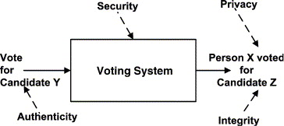

# Results

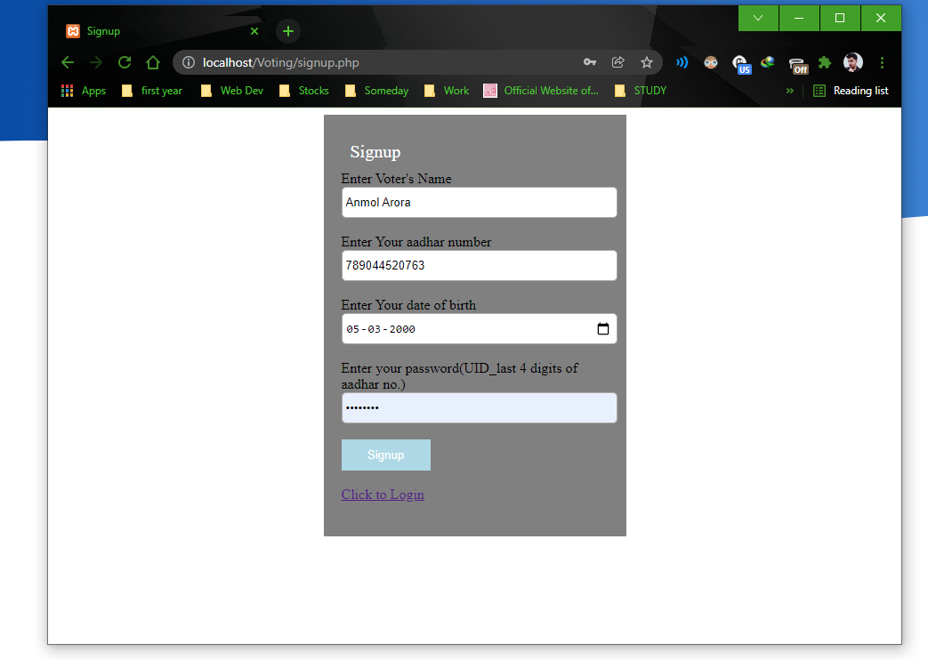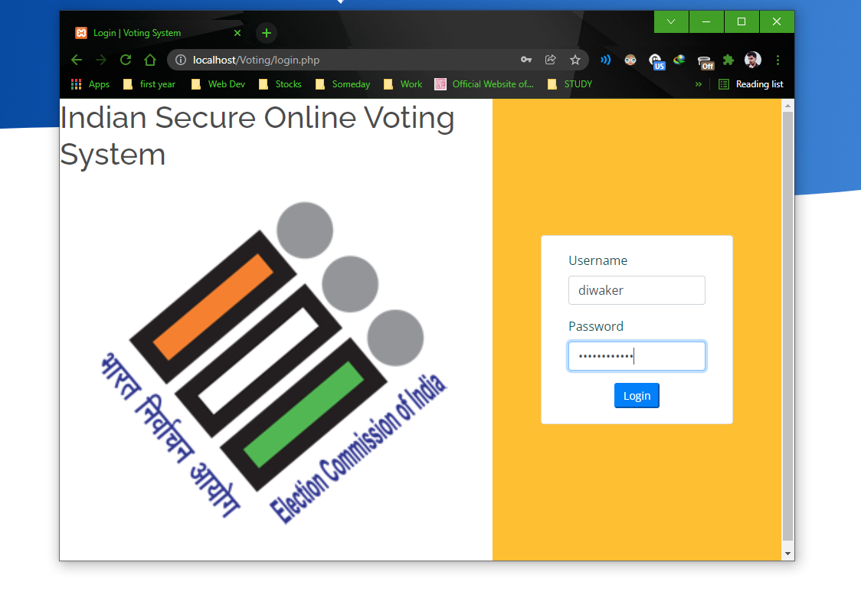

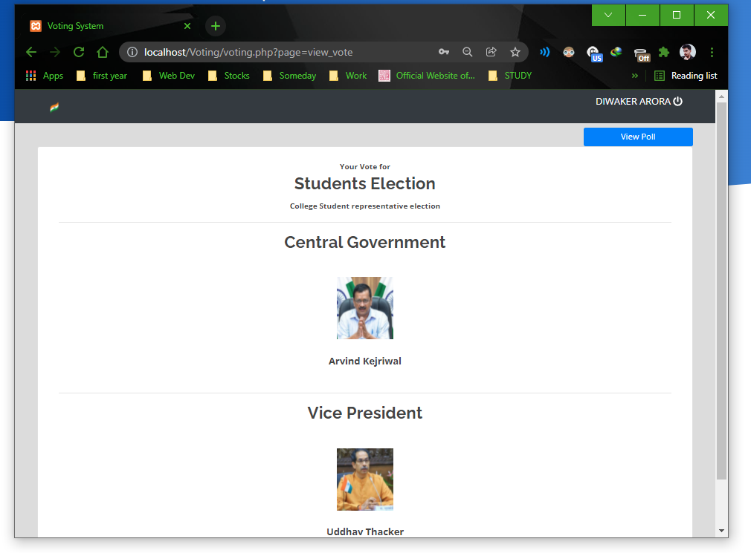

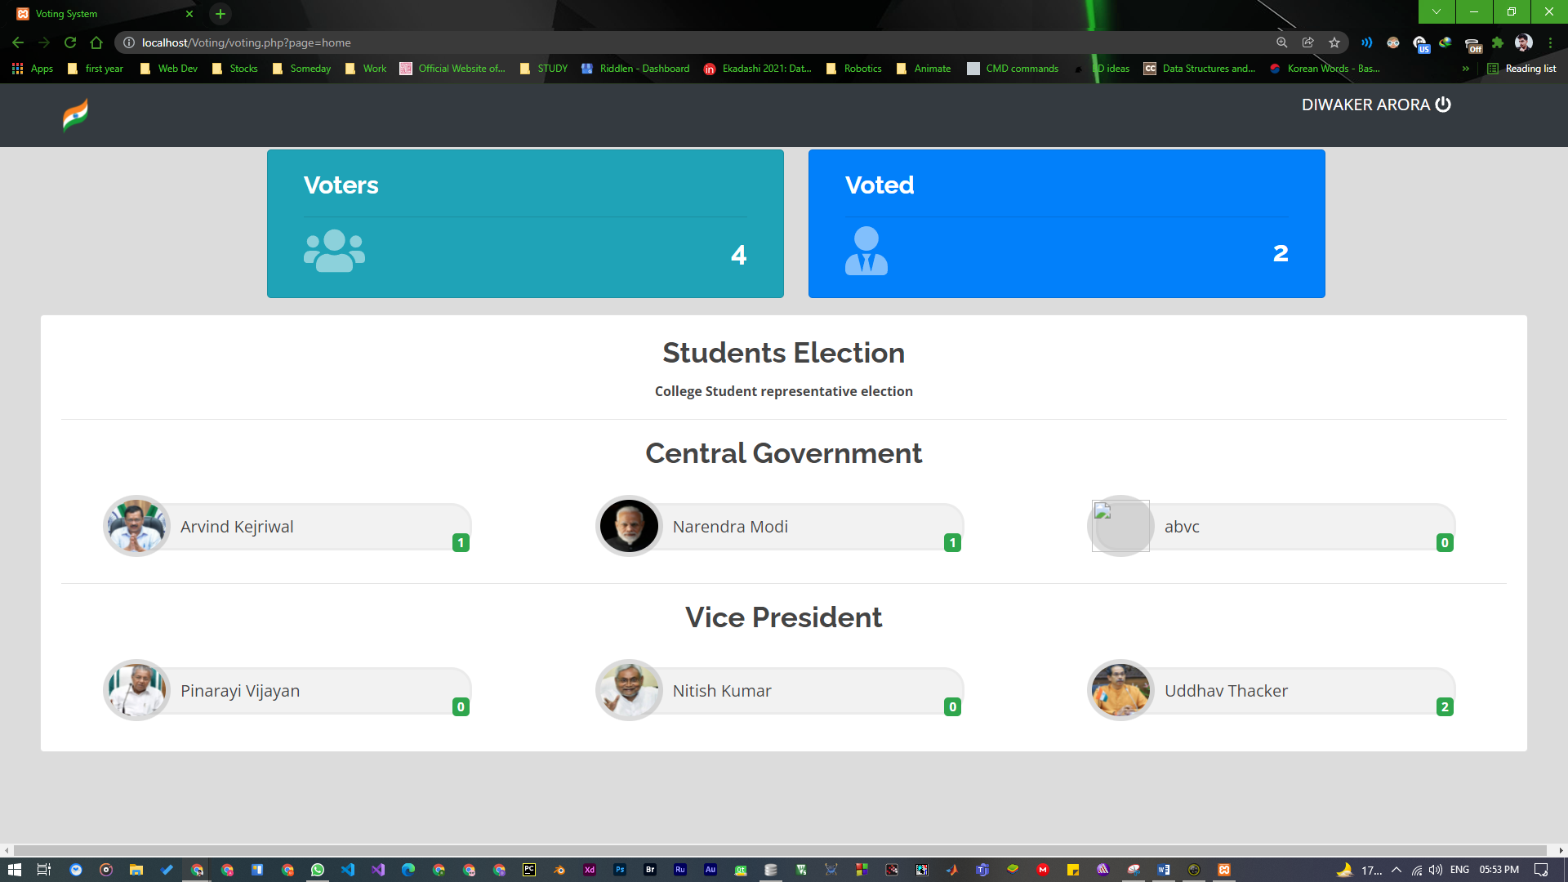

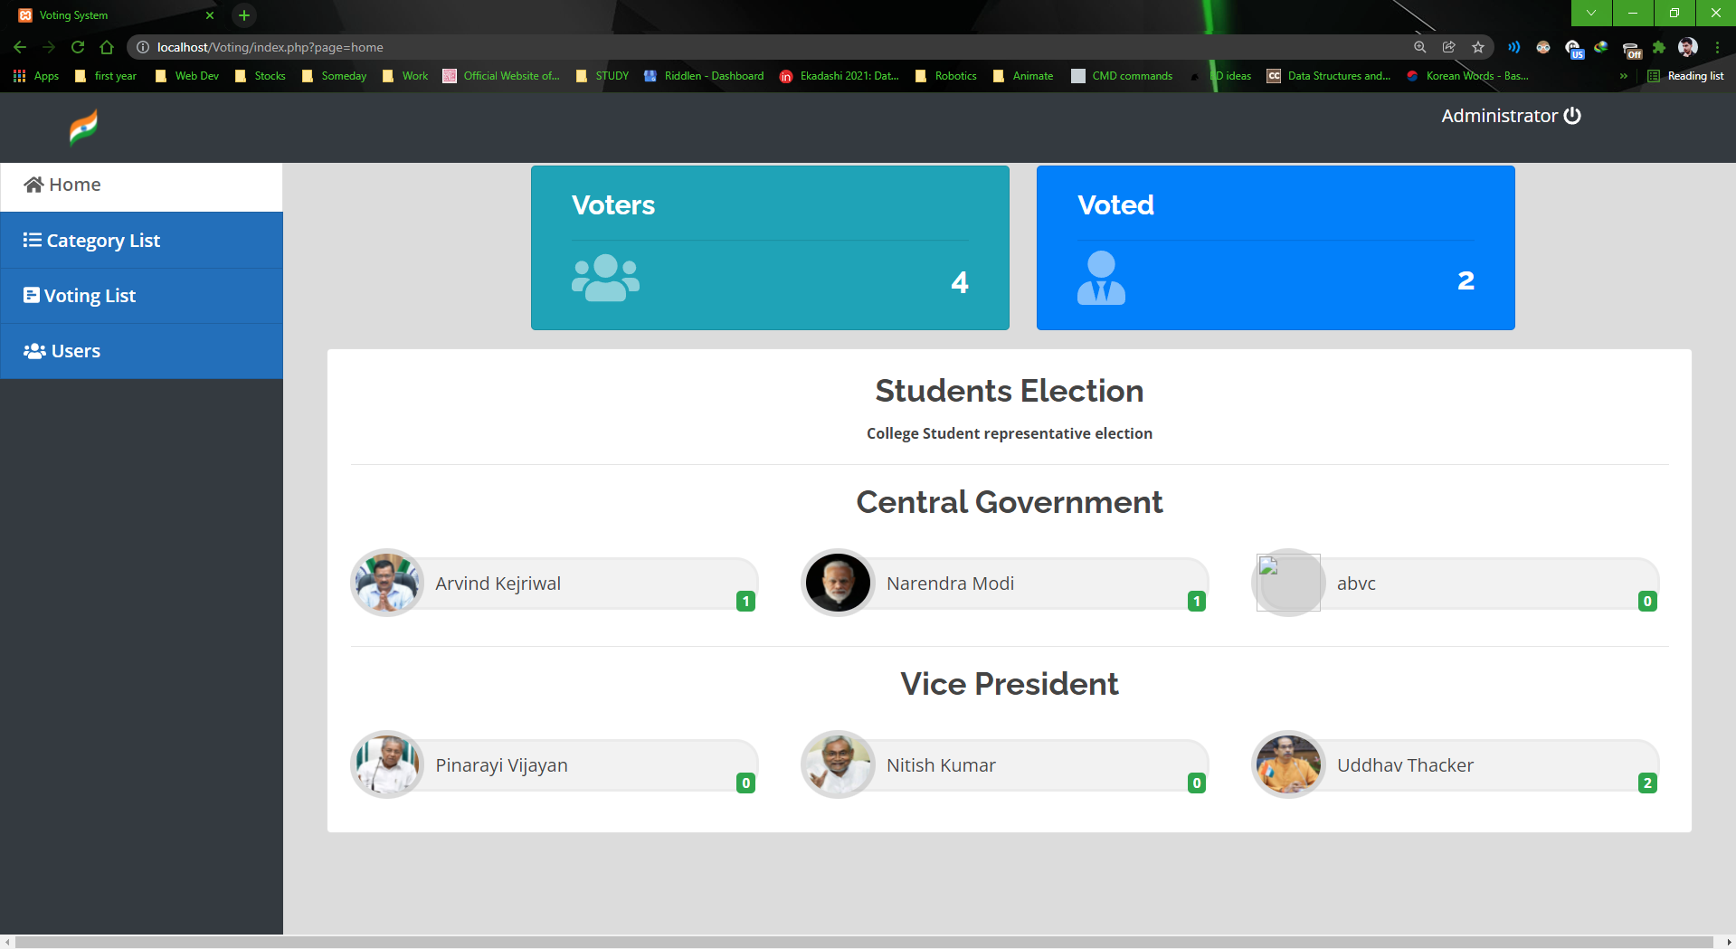

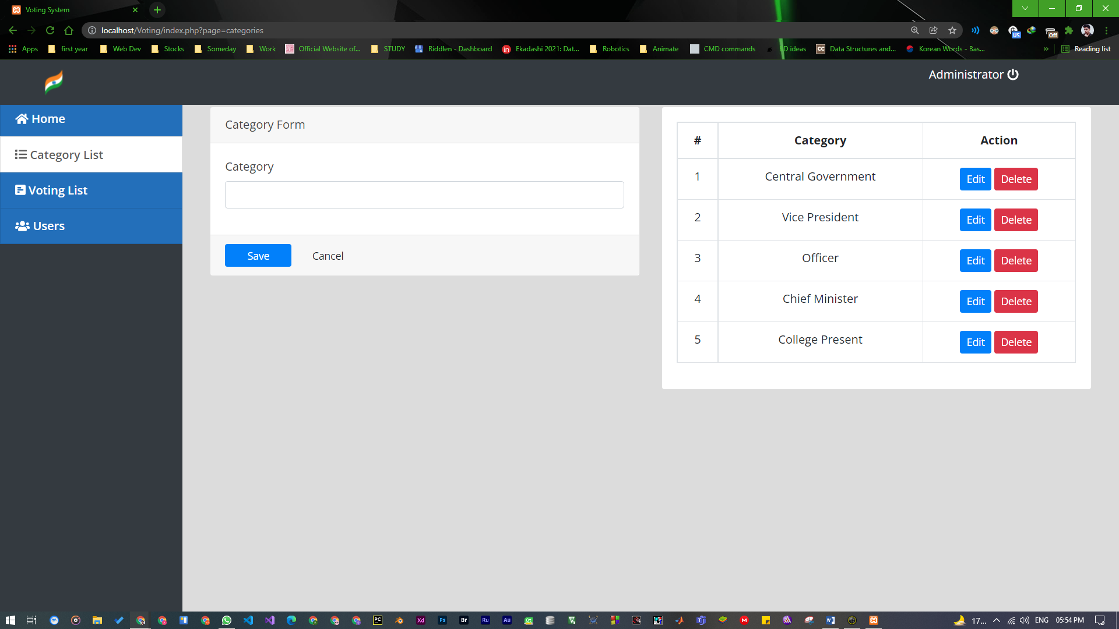

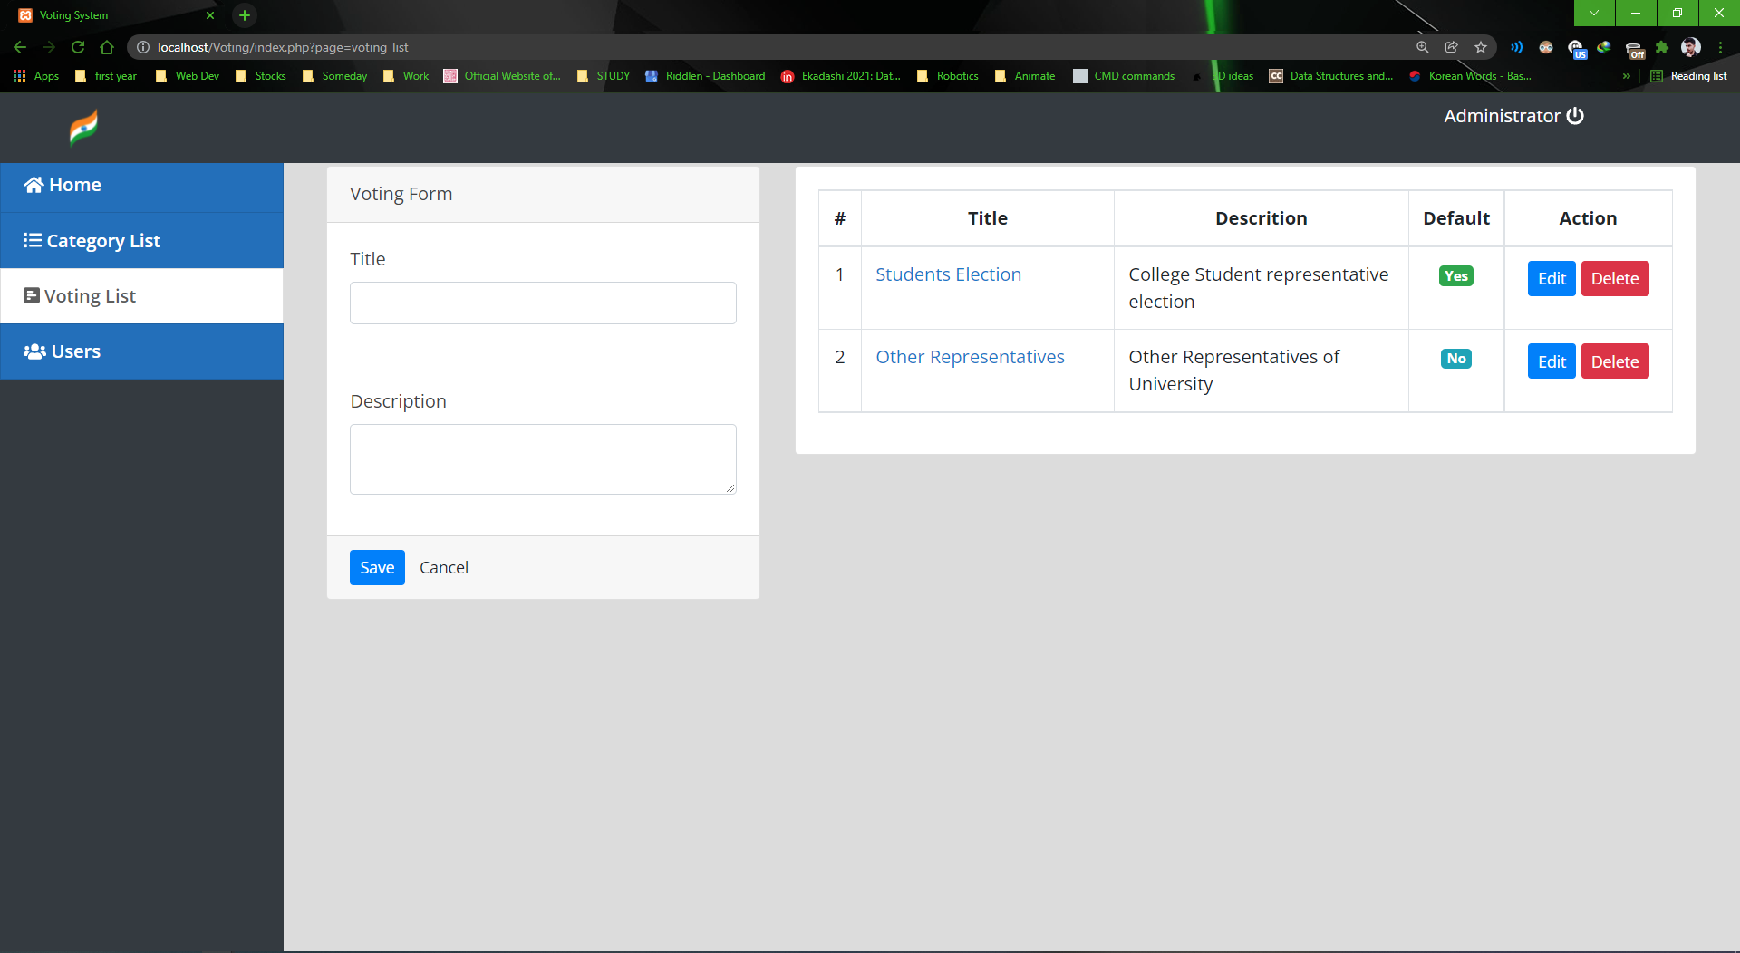

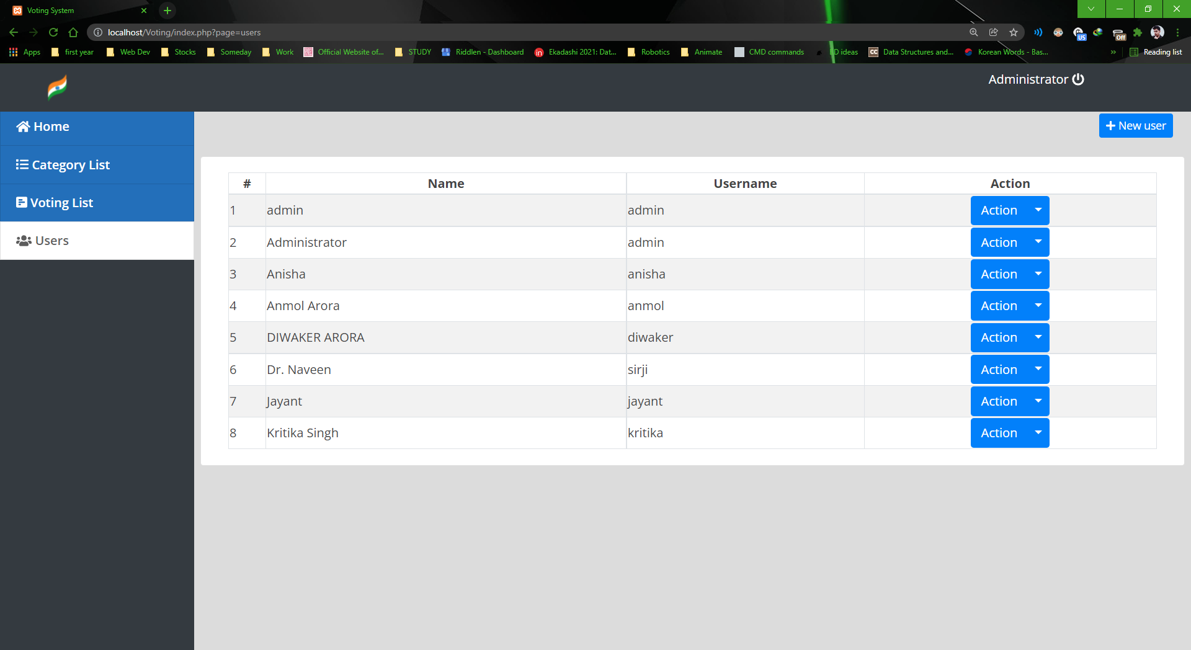

**New Candidate:**

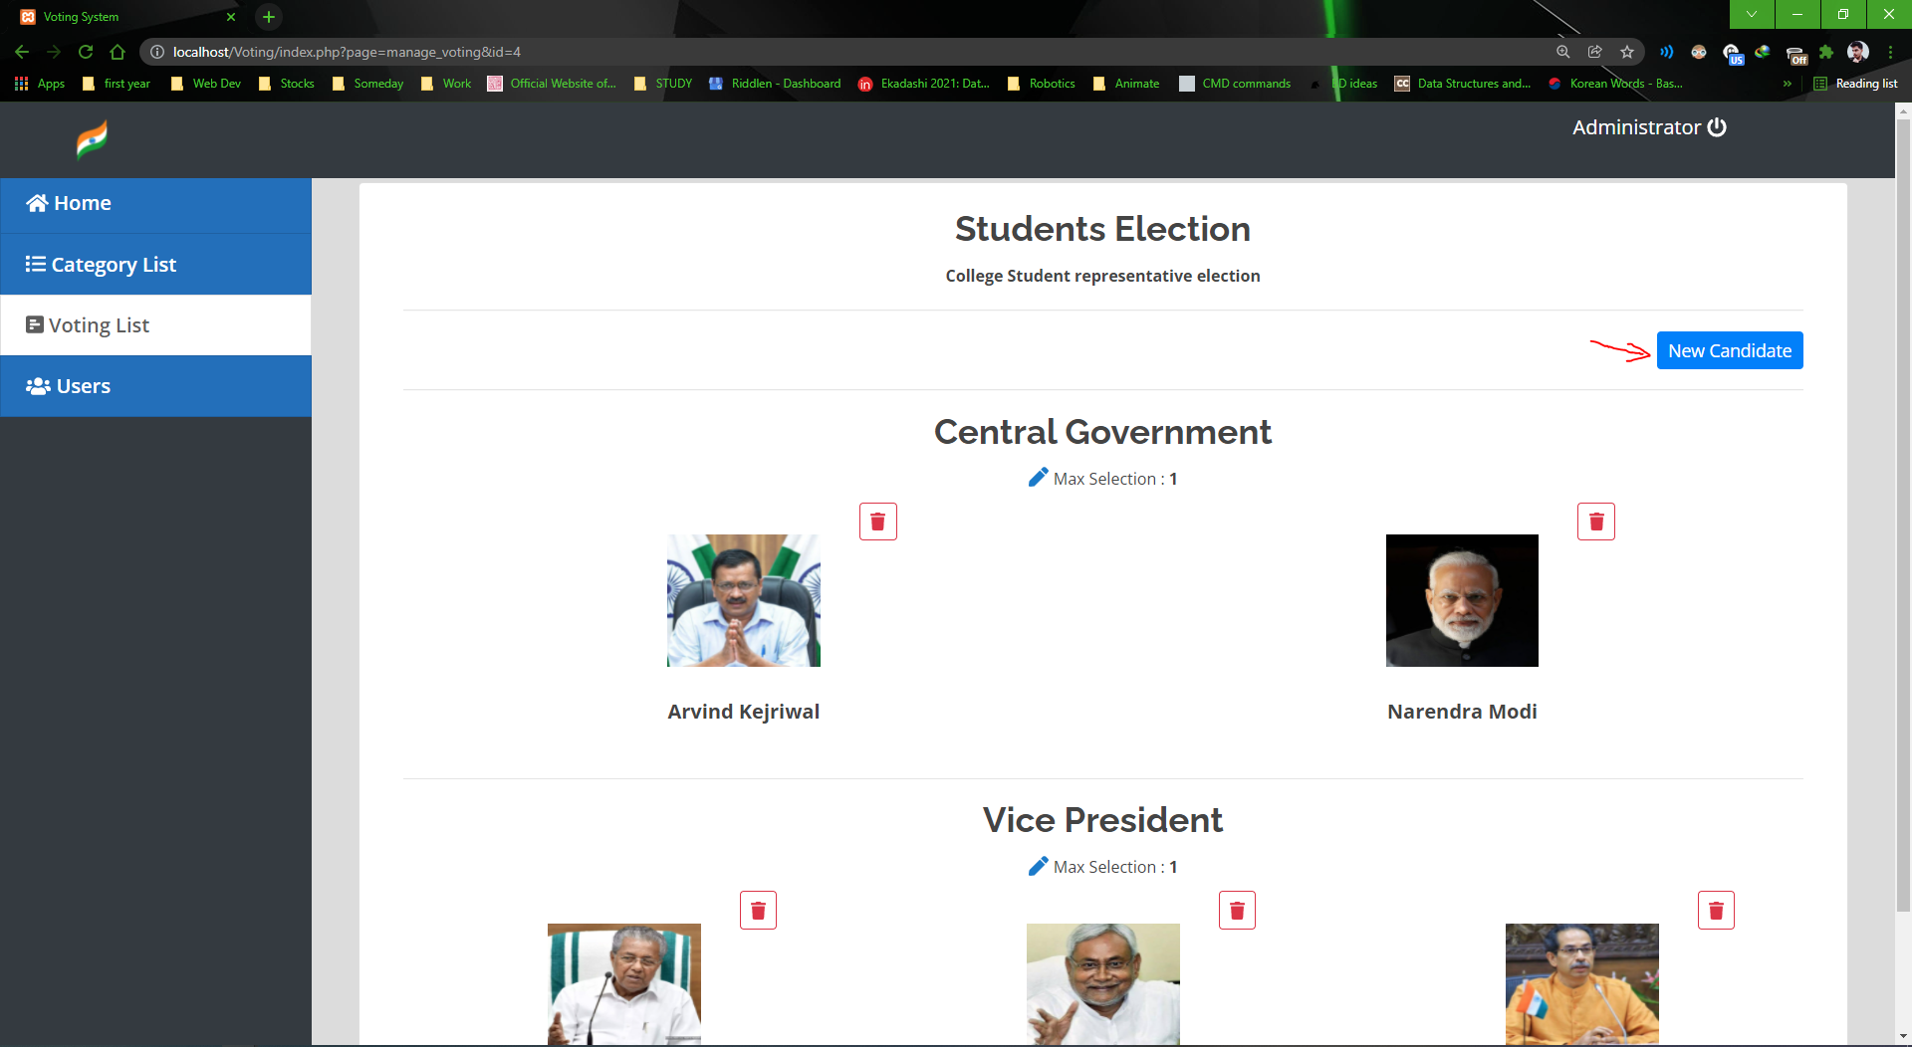

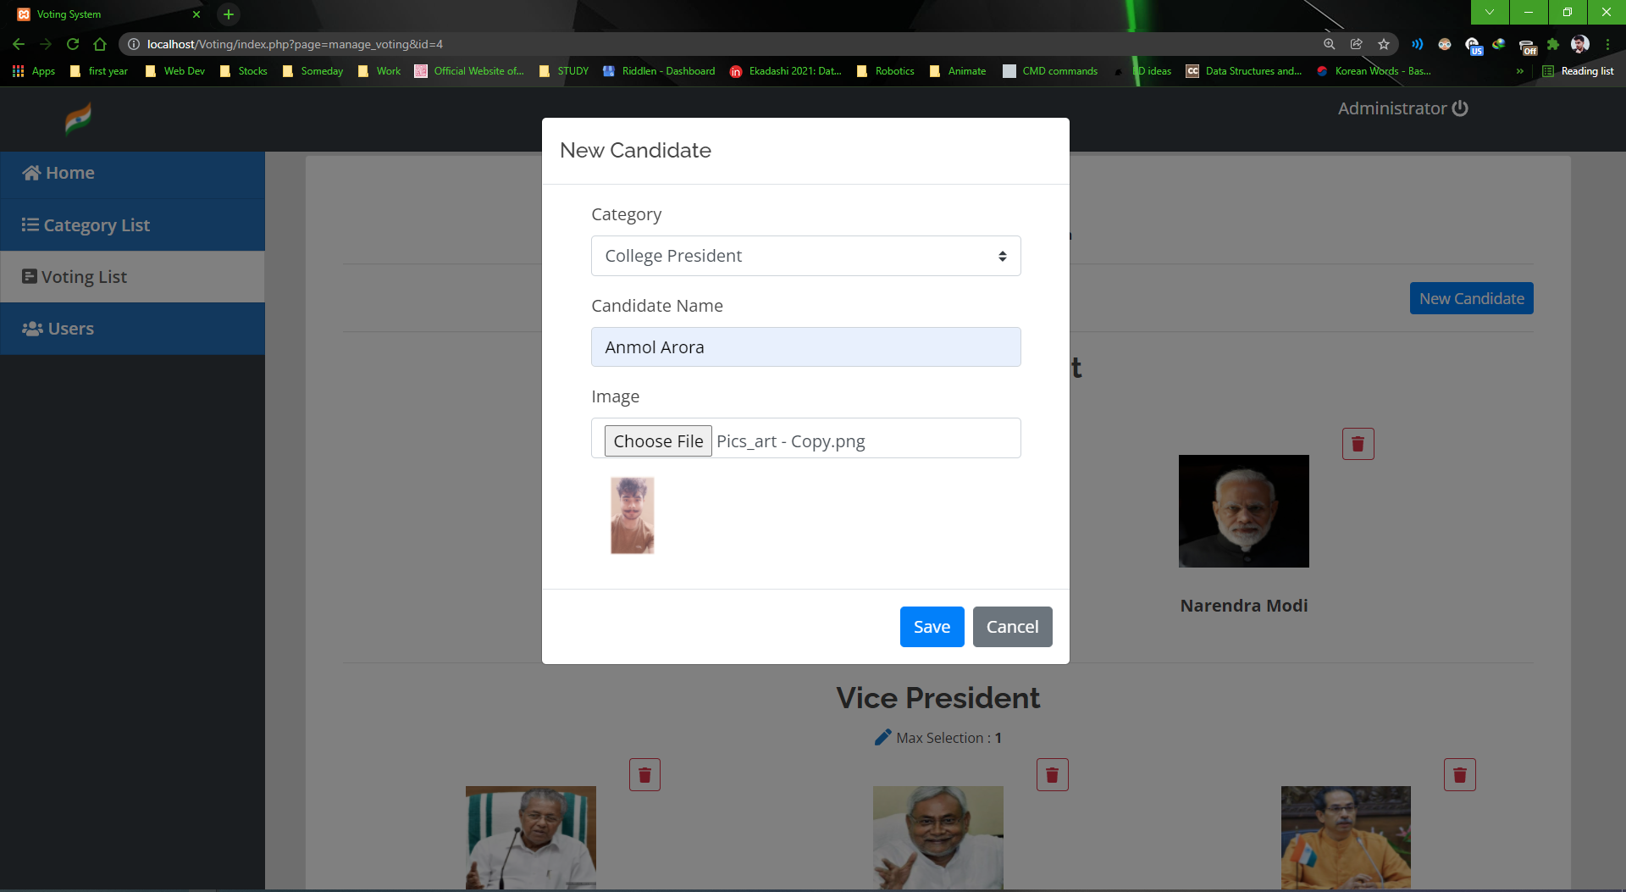

**Data added successfully**

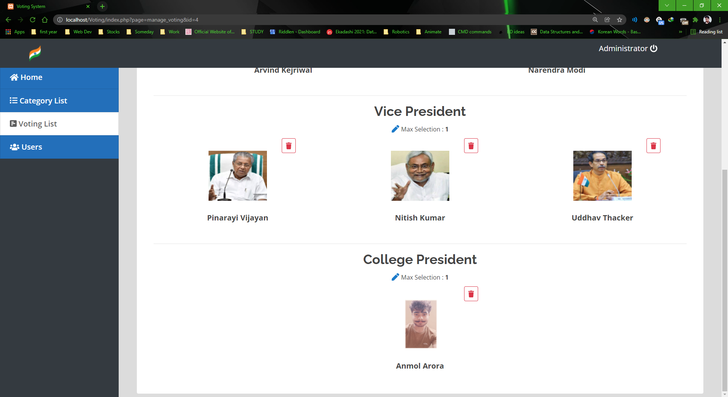

## Source Code:

Landing page:

<style>

    .custom-menu {

        z-index: 1000;

        position: absolute;

        background-color: #ffffff;

        border: 1px solid #0000001c;

        border-radius: 5px;

        padding: 8px;

        min-width: 13vw;

}

a.custom-menu-list {

    width: 100%;

    display: flex;

    color: #4c4b4b;

    font-weight: 600;

    font-size: 1em;

    padding: 1px 11px;

}

    span.card-icon {

    position: absolute;

    font-size: 3em;

    bottom: .2em;

    color: #ffffff80;

}

.file-item{

    cursor: pointer;

}

a.custom-menu-list:hover,.file-item:hover,.file-item.active {

    background: #80808024;

}

table th,td{

    /*border-left:1px solid gray;*/

}

a.custom-menu-list span.icon{

        width:1em;

        margin-right: 5px

}

.candidate {

    margin: auto;

    width: 23vw;

    padding: 0 10px;

    border-radius: 20px;

    margin-bottom: 1em;

    display: flex;

    border: 3px solid #00000008;

    background: #8080801a;

}

.candidate_name {

    margin: 8px;

    margin-left: 3.4em;

    margin-right: 3em;

    width: 100%;

}

    .img-field {

        display: flex;

        height: 8vh;

        width: 4.3vw;

        padding: .3em;

        background: #80808047;

        border-radius: 50%;

        position: absolute;

        left: -.7em;

        top: -.7em;

    }

    .candidate img {

    height: 100%;

    width: 100%;

    margin: auto;

    border-radius: 50%;

}

.vote-field {

    position: absolute;

    right: 0;

    bottom: -.4em;

}

</style>

<div class="containe-fluid">

    <?php include('db_connect.php') ;

    $voting = $conn->query("SELECT * FROM voting_list where  is_default = 1 ");

    foreach ($voting->fetch_array() as $key => $value) {

        $$key = $value;

    }

    $votes  = $conn->query("SELECT * FROM votes where voting_id = $id ");

    $v_arr = array();

    while($row=$votes->fetch_assoc()){

        if(!isset($v_arr[$row['voting_opt_id']]))

            $v_arr[$row['voting_opt_id']] = 0;

        $v_arr[$row['voting_opt_id']] += 1;

    }

    $opts = $conn->query("SELECT * FROM voting_opt where voting_id=".$id);

    $opt_arr = array();

        while($row=$opts->fetch_assoc()){

        $opt_arr[$row['category_id']][] = $row;

    }

    ?>

    <div class="row">

        <div class="col-lg-12">

            <div class="card col-md-4 offset-2 bg-info float-left">

                <div class="card-body text-white">

                    <h4><b>Voters</b></h4>

                    <hr>

                    <span class="card-icon"><i class="fa fa-users"></i></span>

                    <h3 class="text-right"><b><?php echo $conn->query('SELECT * FROM users where type = 2 ')->num_rows ?></b></h3>

                </div>

            </div>

            <div class="card col-md-4 offset-2 bg-primary ml-4 float-left">

                <div class="card-body text-white">

                    <h4><b>Voted</b></h4>

                    <hr>

                    <span class="card-icon"><i class="fa fa-user-tie"></i></span>

                    <h3 class="text-right"><b><?php echo $conn->query('SELECT distinct(user_id) FROM votes where voting_id = '.$id)->num_rows ?></b></h3>

                </div>

            </div>

        </div>

    </div>

    <div class="row mt-3 ml-3 mr-3">

            <div class="col-lg-12">

            <div class="card">

                <div class="card-body">

                    <div class="text-center">

                        <h3><b><?php echo $title ?></b></h3>

                        <small><b><?php echo $description; ?></b></small>

                    </div>

                    <?php

                    $cats = $conn->query("SELECT * FROM category_list where id in (SELECT category_id from voting_opt where voting_id = '".$id."' )");

                    while($row = $cats->fetch_assoc()):

                    ?>

                        <hr>

                        <div class="row mb-4">

                            <div class="col-md-12">

                                    <div class="text-center">

                                        <h3><b><?php echo $row['category'] ?></b></h3>

                                    </div>

                            </div>

                        </div>

                        <div class="row mt-3">

                        <?php foreach ($opt_arr[$row['id']] as $candidate) {

                        ?>

                            <div class="candidate" style="position: relative;">

                                <div class="img-field">

                                    <img src="assets/img/<?php echo $candidate['image_path'] ?>" alt="">

                                </div>

                                <div class="candidate_name"><?php echo $candidate['opt_txt'] ?></div>

                                <div class="vote-field">

                                    <span class="badge badge-success"><large><b><?php echo isset($v_arr[$candidate['id']]) ? number_format($v_arr[$candidate['id']]) : 0 ?></b></large></span>

                                </div>

                            </div>

                        <?php } ?>

                        </div>

                    <?php endwhile; ?>

                </div>

            </div>

        </div>

        </div>

    </div>

</div>

<script>

</script>

Logging In: Index.php

<!DOCTYPE html>

<html lang="en">

<head>

  <meta charset="utf-8">

  <meta content="width=device-width, initial-scale=1.0" name="viewport">

  <title>Voting System</title>

<?php

  session_start();

  if(!isset($_SESSION['login_id']))

    header('location:login.php');

 include('./header.php');

 // include('./auth.php');

 ?>

</head>

<style>

  body{

        background: #80808045;

  }

</style>

<body>

  <?php include 'topbar.php' ?>

  <?php include 'navbar.php' ?>

  <div class="toast" id="alert_toast" role="alert" aria-live="assertive" aria-atomic="true">

    <div class="toast-body text-white">

    </div>

  </div>

  <main id="view-panel" >

      <?php $page = isset($_GET['page']) ? $_GET['page'] :'home'; ?>

    <?php include $page.'.php' ?>

  </main>

  <div id="preloader"></div>

  <a href="#" class="back-to-top"><i class="icofont-simple-up"></i></a>

<div class="modal fade" id="confirm_modal" role='dialog'>

    <div class="modal-dialog modal-md" role="document">

      <div class="modal-content">

        <div class="modal-header">

        <h5 class="modal-title">Confirmation</h5>

      </div>

      <div class="modal-body">

        <div id="delete_content"></div>

      </div>

      <div class="modal-footer">

        <button type="button" class="btn btn-primary" id='confirm' onclick="">Continue</button>

        <button type="button" class="btn btn-secondary" data-dismiss="modal">Close</button>

      </div>

      </div>

    </div>

  </div>

  <div class="modal fade" id="uni_modal" role='dialog'>

    <div class="modal-dialog modal-md" role="document">

      <div class="modal-content">

        <div class="modal-header">

        <h5 class="modal-title"></h5>

      </div>

      <div class="modal-body">

      </div>

      <div class="modal-footer">

        <button type="button" class="btn btn-primary" id='submit' onclick="$('#uni_modal form').submit()">Save</button>

        <button type="button" class="btn btn-secondary" data-dismiss="modal">Cancel</button>

      </div>

      </div>

    </div>

  </div>

</body>

<script>

   window.start_load = function(){

    $('body').prepend('<di id="preloader2"></di>')

  }

  window.end_load = function(){

    $('#preloader2').fadeOut('fast', function() {

        $(this).remove();

      })

  }

  window.uni_modal = function($title = '' , $url=''){

    start_load()

    $.ajax({

        url:$url,

        error:err=>{

            console.log()

            alert("An error occured")

        },

        success:function(resp){

            if(resp){

                $('#uni_modal .modal-title').html($title)

                $('#uni_modal .modal-body').html(resp)

                $('#uni_modal').modal('show')

                end_load()

            }

        }

    })

}

window._conf = function($msg='',$func='',$params = []){

     $('#confirm_modal #confirm').attr('onclick',$func+"("+$params.join(',')+")")

     $('#confirm_modal .modal-body').html($msg)

     $('#confirm_modal').modal('show')

  }

   window.alert_toast= function($msg = 'TEST',$bg = 'success'){

      $('#alert_toast').removeClass('bg-success')

      $('#alert_toast').removeClass('bg-danger')

      $('#alert_toast').removeClass('bg-info')

      $('#alert_toast').removeClass('bg-warning')

    if($bg == 'success')

      $('#alert_toast').addClass('bg-success')

    if($bg == 'danger')

      $('#alert_toast').addClass('bg-danger')

    if($bg == 'info')

      $('#alert_toast').addClass('bg-info')

    if($bg == 'warning')

      $('#alert_toast').addClass('bg-warning')

    $('#alert_toast .toast-body').html($msg)

    $('#alert_toast').toast({delay:3000}).toast('show');

  }

  $(document).ready(function(){

    $('#preloader').fadeOut('fast', function() {

        $(this).remove();

      })

  })

</script>

</html>

Login.php

<!DOCTYPE html>

<html lang="en">

<head>

  <meta charset="utf-8">

  <meta content="width=device-width, initial-scale=1.0" name="viewport">

  <title>Login | Voting System</title>

<?php include('./header.php'); ?>

<?php

session_start();

if(isset($_SESSION['login_id']))

header("location:index.php?page=home");

?>

</head>

<style>

    body{

        width: 100%;

        height: calc(100%);

        /*background: #007bff;*/

    }

    main#main{

        width:100%;

        height: calc(100%);

        background:white;

    }

    #login-right{

        position: absolute;

        right:0;

        width:40%;

        height: calc(100%);

        background:white;

        display: flex;

        align-items: center;

    }

    #login-left{

        position: absolute;

        left:0;

        width:60%;

        height: calc(100%);

        background:white;

        display: flex;

        align-items: center;

    }

    #login-right .card{

        margin: auto

    }

    .logo {

    margin: auto;

    font-size: 8rem;

    /*background: #00000061;*/

    /*padding: .5em 0.8em;*/

    /*border-radius: 50% 50%;*/

    color: #000000b3;

}

</style>

<body>

  <main id="main" class=" alert-info">

        <div id="login-left">

            <div class="logo">

                <h1>Indian Secure Online Voting System</h1>

                <img src="logo.png" alt="..." width="100%">

            </div>

        </div>

        <div id="login-right" class="bg-warning">

            <div class="card col-md-8">

                <div class="card-body">

                    <form id="login-form" >

                        <div class="form-group">

                            <label for="username" class="control-label">Username</label>

                            <input type="text" id="username" name="username" class="form-control">

                        </div>

                        <div class="form-group">

                            <label for="password" class="control-label">Password</label>

                            <input type="password" id="password" name="password" class="form-control">

                        </div>

                        <center><button class="btn-sm btn-block btn-wave col-md-4 btn-primary">Login</button></center>

                    </form>

                </div>

            </div>

        </div>

  </main>

  <a href="#" class="back-to-top"><i class="icofont-simple-up"></i></a>

</body>

<script>

    $('#login-form').submit(function(e){

        e.preventDefault()

        $('#login-form button[type="button"]').attr('disabled',true).html('Logging in...');

        if($(this).find('.alert-danger').length > 0 )

            $(this).find('.alert-danger').remove();

        $.ajax({

            url:'ajax.php?action=login',

            method:'POST',

            data:$(this).serialize(),

            error:err=>{

                console.log(err)

        $('#login-form button[type="button"]').removeAttr('disabled').html('Login');

            },

            success:function(resp){

                if(resp == 1){

                    location.href ='index.php?page=home';

                }else if(resp == 2){

                    location.href ='voting.php';

                }else{

                    $('#login-form').prepend('<div class="alert alert-danger">Username or password is incorrect.</div>')

                    $('#login-form button[type="button"]').removeAttr('disabled').html('Login');

                }

            }

        })

    })

</script>

</html>

Authentication Using Adhaar Card Number

<?php

function check_login($conn)

{

    if(isset($_SESSION['aadhar_id']))

    {

        $id = $_SESSION['aadhar_id'];

        $query = "select * from voters where aadhar_id = '$id' limit 1";

        $result = mysqli_query($conn,$query);

        if($result && mysqli_num_rows($result) > 0)

        {

            $user_data = mysqli_fetch_assoc($result);

            return $user_data;

        }

    }

    //redirect to login

    header("Location: login.php");

    die;

}

# Connecting DataBase:

<?php

$conn= new mysqli('localhost','root','','voting_db')or die("Could not connect to mysql".mysqli_error($con));

Header file for importing

<meta content="" name="descriptison">

  <meta content="" name="keywords">

  <!-- Google Fonts -->

  <link href="https://fonts.googleapis.com/css?family=Open+Sans:300,300i,400,400i,600,600i,700,700i|Raleway:300,300i,400,400i,500,500i,600,600i,700,700i|Poppins:300,300i,400,400i,500,500i,600,600i,700,700i" rel="stylesheet">

    <link rel="stylesheet" href="assets/font-awesome/css/all.min.css">

  <!-- Vendor CSS Files -->

  <link href="assets/vendor/bootstrap/css/bootstrap.min.css" rel="stylesheet">

  <link href="assets/vendor/icofont/icofont.min.css" rel="stylesheet">

  <link href="assets/vendor/boxicons/css/boxicons.min.css" rel="stylesheet">

  <link href="assets/vendor/venobox/venobox.css" rel="stylesheet">

  <link href="assets/vendor/animate.css/animate.min.css" rel="stylesheet">

  <link href="assets/vendor/remixicon/remixicon.css" rel="stylesheet">

  <link href="assets/vendor/owl.carousel/assets/owl.carousel.min.css" rel="stylesheet">

  <link href="assets/vendor/bootstrap-datepicker/css/bootstrap-datepicker.min.css" rel="stylesheet">

  <link href="assets/DataTables/datatables.min.css" rel="stylesheet">

  <!-- Template Main CSS File -->

  <link href="assets/css/style.css" rel="stylesheet">

  <link type="text/css" rel="stylesheet" href="assets/css/jquery-te-1.4.0.css">

  <script src="assets/vendor/jquery/jquery.min.js"></script>

  <script src="assets/DataTables/datatables.min.js"></script>

  <script src="assets/vendor/bootstrap/js/bootstrap.bundle.min.js"></script>

  <script src="assets/vendor/jquery.easing/jquery.easing.min.js"></script>

  <script src="assets/vendor/php-email-form/validate.js"></script>

  <script src="assets/vendor/venobox/venobox.min.js"></script>

  <script src="assets/vendor/waypoints/jquery.waypoints.min.js"></script>

  <script src="assets/vendor/counterup/counterup.min.js"></script>

  <script src="assets/vendor/owl.carousel/owl.carousel.min.js"></script>

  <script src="assets/vendor/bootstrap-datepicker/js/bootstrap-datepicker.min.js"></script>

    <script type="text/javascript" src="assets/font-awesome/js/all.min.js"></script>

  <script type="text/javascript" src="assets/js/jquery-te-1.4.0.min.js" charset="utf-8"></script>

**Sign Up:**

<?php

session_start();

    include("db_connect.php");

    include("functions.php");

    if($_SERVER['REQUEST_METHOD'] == "POST")

    {

        //something was posted

        $password = $_POST['password'];

        $aadhar_id=$_POST['aadhar_id'];

        $dob=$_POST['dob'];

        $name=$_POST['name'];

        if(!empty($password) && !empty($aadhar_id) && !empty($name))

        {

            //save to database

            //$user_id = random_num(20);

            $query = "insert into voters (name,dob,aadhar_id,password) values ('$name','$dob','$aadhar_id','$password')";

            mysqli_query($conn, $query);

            header("Location: login.php");

            die;

        }else

        {

            echo "Please enter some valid information!";

        }

    }

?>

<!DOCTYPE html>

<html>

<head>

    <title>Signup</title>

</head>

<body>

    <style type="text/css">

    #text{

        height: 25px;

        border-radius: 5px;

        padding: 4px;

        border: solid thin #aaa;

        width: 100%;

    }

    #button{

        padding: 10px;

        width: 100px;

        color: white;

        background-color: lightblue;

        border: none;

    }

    #box{

        background-color: grey;

        margin: auto;

        width: 300px;

        padding: 20px;

    }

    </style>

    <div id="box">

        <form method="post">

            <div style="font-size: 20px;margin: 10px;color: white;">Signup</div>

            <label>Enter Voter's Name</label><br>

            <input id="text" type="text" name="name"><br><br>

            <label>Enter Your aadhar number</label><br>

            <input id="text" type="text" name="aadhar_id"><br><br>

            <label>Enter Your date of birth</label><br>

            <input id="text" type="date" name="dob"><br><br>

            <label>Enter your password(UID_last 4 digits of aadhar no.)</label><br>

            <input id="text" type="password" name="password"><br><br>

            <input id="button" type="submit" value="Signup"><br><br>

            <a href="login.php">Click to Login</a><br><br>

        </form>

    </div>

</body>

</html>

**Users database:**

<?php

?>

<div class="container-fluid">

    <div class="row">

    <div class="col-lg-12">

            <button class="btn btn-primary float-right btn-sm" id="new_user"><i class="fa fa-plus"></i> New user</button>

    </div>

    </div>

    <br>

    <div class="row">

        <div class="card col-lg-12">

            <div class="card-body">

                <table class="table-striped table-bordered col-md-12">

            <thead>

                <tr>

                    <th class="text-center">#</th>

                    <th class="text-center">Name</th>

                    <th class="text-center">Username</th>

                    <th class="text-center">Action</th>

                </tr>

            </thead>

            <tbody>

                <?php

                    include 'db_connect.php';

                    $users = $conn->query("SELECT * FROM users order by name asc");

                    $i = 1;

                    while($row= $users->fetch_assoc()):

                 ?>

                 <tr>

                    <td>

                        <?php echo $i++ ?>

                    </td>

                    <td>

                        <?php echo $row['name'] ?>

                    </td>

                    <td>

                        <?php echo $row['username'] ?>

                    </td>

                    <td>

                        <center>

                                <div class="btn-group">

                                  <button type="button" class="btn btn-primary">Action</button>

                                  <button type="button" class="btn btn-primary dropdown-toggle dropdown-toggle-split" data-toggle="dropdown" aria-haspopup="true" aria-expanded="false">

                                    <span class="sr-only">Toggle Dropdown</span>

                                  </button>

                                  <div class="dropdown-menu">

                                    <a class="dropdown-item edit_user" href="javascript:void(0)" data-id = '<?php echo $row['id'] ?>'>Edit</a>

                                    <div class="dropdown-divider"></div>

                                    <a class="dropdown-item delete_user" href="javascript:void(0)" data-id = '<?php echo $row['id'] ?>'>Delete</a>

                                  </div>

                                </div>

                                </center>

                    </td>

                 </tr>

                <?php endwhile; ?>

            </tbody>

        </table>

            </div>

        </div>

    </div>

</div>

<script>

$('#new_user').click(function(){

    uni_modal('New User','manage_user.php')

})

$('.edit_user').click(function(){

    uni_modal('Edit User','manage_user.php?id='+$(this).attr('data-id'))

})

</script>

**Voting database reporting**

<!DOCTYPE html>

<html lang="en">

<head>

  <meta charset="utf-8">

  <meta content="width=device-width, initial-scale=1.0" name="viewport">

  <title>Voting System</title>

<?php

  session_start();

  if(!isset($_SESSION['login_id']))

    header('location:login.php');

 include('./header.php');

 // include('./auth.php');

 ?>

</head>

<style>

  body{

        background: #80808045;

  }

  main{

    margin-left: unset !important;

    width: calc(100%) !important

  }

</style>

<body>

  <?php include 'topbar.php' ?>

  <div class="toast" id="alert_toast" role="alert" aria-live="assertive" aria-atomic="true">

    <div class="toast-body text-white">

    </div>

  </div>

  <main id="view-panel" >

      <?php $page = isset($_GET['page']) ? $_GET['page'] :'vote_sheet'; ?>

    <?php include $page.'.php' ?>

  </main>

  <div id="preloader"></div>

  <a href="#" class="back-to-top"><i class="icofont-simple-up"></i></a>

<div class="modal fade" id="confirm_modal" role='dialog'>

    <div class="modal-dialog modal-md" role="document">

      <div class="modal-content">

        <div class="modal-header">

        <h5 class="modal-title">Confirmation</h5>

      </div>

      <div class="modal-body">

        <div id="delete_content"></div>

      </div>

      <div class="modal-footer">

        <button type="button" class="btn btn-primary" id='confirm' onclick="">Continue</button>

        <button type="button" class="btn btn-secondary" data-dismiss="modal">Close</button>

      </div>

      </div>

    </div>

  </div>

  <div class="modal fade" id="uni_modal" role='dialog'>

    <div class="modal-dialog modal-md" role="document">

      <div class="modal-content">

        <div class="modal-header">

        <h5 class="modal-title"></h5>

      </div>

      <div class="modal-body">

      </div>

      <div class="modal-footer">

        <button type="button" class="btn btn-primary" id='submit' onclick="$('#uni_modal form').submit()">Save</button>

        <button type="button" class="btn btn-secondary" data-dismiss="modal">Cancel</button>

      </div>

      </div>

    </div>

  </div>

</body>

<script>

   window.start_load = function(){

    $('body').prepend('<di id="preloader2"></di>')

  }

  window.end_load = function(){

    $('#preloader2').fadeOut('fast', function() {

        $(this).remove();

      })

  }

  window.uni_modal = function($title = '' , $url=''){

    start_load()

    $.ajax({

        url:$url,

        error:err=>{

            console.log()

            alert("An error occured")

        },

        success:function(resp){

            if(resp){

                $('#uni_modal .modal-title').html($title)

                $('#uni_modal .modal-body').html(resp)

                $('#uni_modal').modal('show')

                end_load()

            }

        }

    })

}

window._conf = function($msg='',$func='',$params = []){

     $('#confirm_modal #confirm').attr('onclick',$func+"("+$params.join(',')+")")

     $('#confirm_modal .modal-body').html($msg)

     $('#confirm_modal').modal('show')

  }

   window.alert_toast= function($msg = 'TEST',$bg = 'success'){

      $('#alert_toast').removeClass('bg-success')

      $('#alert_toast').removeClass('bg-danger')

      $('#alert_toast').removeClass('bg-info')

      $('#alert_toast').removeClass('bg-warning')

    if($bg == 'success')

      $('#alert_toast').addClass('bg-success')

    if($bg == 'danger')

      $('#alert_toast').addClass('bg-danger')

    if($bg == 'info')

      $('#alert_toast').addClass('bg-info')

    if($bg == 'warning')

      $('#alert_toast').addClass('bg-warning')

    $('#alert_toast .toast-body').html($msg)

    $('#alert_toast').toast({delay:3000}).toast('show');

  }

  $(document).ready(function(){

    $('#preloader').fadeOut('fast', function() {

        $(this).remove();

      })

  })

</script>

</html>

# CONCLUSION

Online voting system is developed by using PHP as front end and My SQL for database in back end to computerize the process for check in and out system.

The project covers only the basic required to sum up, developing a information system on “online voting system” for was a matter of essence

# REFERENCES

* <https://getbootstrap.com/>
* <https://www.tutorialspoint.com/php/index.htm>
* <https://www.w3schools.com/php/>
* <https://create.arduino.cc/projecthub/DCamino/ambient-light-sensor-using-photo-resistor-> [and-led-lights-9b7f39](https://create.arduino.cc/projecthub/DCamino/ambient-light-sensor-using-photo-resistor-and-led-lights-9b7f39)
* <https://www.eballot.com/votes-and-elections/what-is-an-online-voting-system>
* <https://www.researchgate.net/publication/340234262_DESIGN_AND_IMPLEMENTATION_OF_AN_E-VOTING_SYSTEM>
* <https://electionrunner.com/>
* <https://ieeexplore.ieee.org/document/6756265?reload=true>